Pokhara University

Level: Bachelor | Semester – Spring | Year : 2005
Programme: BE |  | Full Marks : 100
Course: Chemistry |  | Time : 3hrs.

Candidates are required to give their answers in their own words as far as practicable.
The figures in the margin indicate full marks.

Attempt all the questions.

1. | - Derive the expression to calculate the total energy of electron in the orbit of H-atom. Calculate the wavelength of electron when it jumps from 5th spectral line of Balmer series. [Rydberg's constant R = 1.0973737×10⁷ m⁻¹]  - "Quantum numbers give complete address of electron in 3-dimensional space", justify the statement. Calculate the velocity of electron when it is revolving in the 4th orbit of hydrogen atom. [mass of e– = 9.1091×10⁻³¹ kg radius of 1st orbit, r₁ = 0.529×10^{–10}m and Plank's constant, h = 6.62×10^{–34} Js] | 5+3  4+3
2. | - Define acidic & basic buffer solutions with suitable example. Derive the equation by which pH of an acidic buffer solution can be calculated. If the dissociation constant of acetic acid is 1.8×10^{–5} then calculate the degree of dissociation of 0.02M acetic acid solution at particular temperature.  - What do you mean by redox reaction? Explain it by taking the example of the system Zn(s)/Zn⁺⁺ (0.02M)//Ni⁺⁺ (0.5m)/Ni (s). Also calculate the emf of above cell at 25⁰C & draw the cell diagram.  Given:  Eº _{Zn++/Zn} = – 0.67v R = 8.314 C mol^{–1}  Eo Ni⁺⁺/Ni = – 0.23v F = 96500C | 2+3+2  2+3+3
3. | a) Define ionization energy. Explain the factors which affect the value of ionization energy. Nitrogen has higher IE than oxygen. Why?  b) Give reason:  i) Zn, Cd & Hg are not considered as transition elements.  ii) Transition metals are colourful  OR  - Define electronegativity. How does electronegativity vary along the groups & periods in the periodic table? Explain why electronegativity of Gallium is higher than Aluminium?  - What are transition elements? Explain why they posses following characteristic properties:  - They are paramagnetic in nature  - They form complexes  - They have high m.p. & B.P. | 7+2  2×3  6+2  7
4. | a) Define ionic bonds. Write the characteristic feature of ionic compounds.  b) Explain the mode of hybridization in BF3 molecule.  c) Explain molecular orbital theory of bonding with suitable example | 1+4  5  5
5. | a) Write the IUPAC name of following organic compounds:  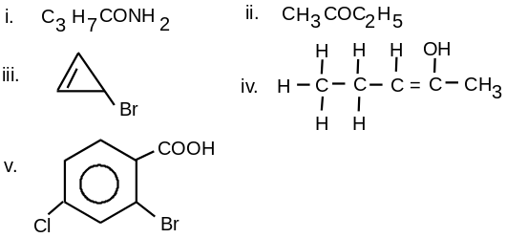 | 1x5
 | b) Explain hyper conjugation. Explain the stability of Carbon free radicals with the help of hyper conjugation  c) Define carbanions. Discuss any two methods of its generation. | 3+2  2+3
6. | a) Compare the mechanism of SN1 reaction with E1 reaction. Why stereochemistry of SN1 reaction is racemization.  b) What is polymer? Explain condensation polymerisation with suitable example.  OR  - Write the mechanism of following reactions  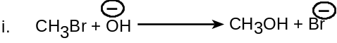  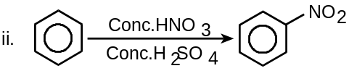 | 8+2  5  2x5
 | b) Differentiate between thermoplastics & thermosetting plastics. | 5
7. | Write short notes on (Any Two):  - Dissolved oxygen  - Shape of p-orbitals  - Electro chemical series  - Global warming | 2x5

